How to Use this Template
Andrea Petz¹ and Samfrom Elsewhere²
¹Institute Integriert Studieren, JKU Linz, Austria
²Research Center for the Really Important Things (RIT), Company, City, Country
Corresponding.Author@institution.ct

Abstract
Give a sound overview, no paragraphs, no foot nor endnotes, no pictures, no columns, no bullets, no lists, no tables and stay within 250 WORDS.

Introduction
Give your readers a chance to get used to your topic. No need for extended references, but cite wherever necessary

Our Work
What did you do and how did you do it? Give some words on your approach and methodology and tell people why you did it like you did it.
Try to keep a practical orientation in your paper – give pictures, graphs and describe them in order to be useful and understandable.
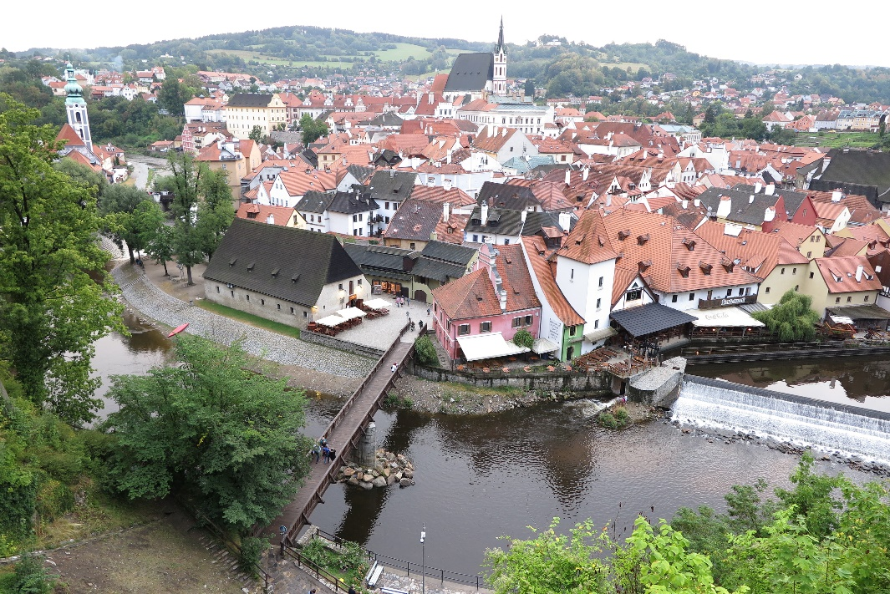
Picture 1: Description of what people see in the picture – use the built-in Word description feature for pictures by right clicking the picture.
Try to make the picture small enough for people not to lose he context (text) but be big enough that people can see what is on the pic. Give the built-in “description and numbering” from Word for it and use a new paragraph for the description.
Same applies for tables, but the description should be ABOVE the table (use the built in numbering and description template by right clicking the table!) and the table itself should be placed as a whole on one page (no tables crossing to next page, enter a page break before your table if needed) and placed “centered”:
Table 1: Whatever is interesting to tell your audience about the table (sample size, …)
 | A | B
1 | result1 | result2
2 | result 1 | result 2

Headings
Use a new paragraph for all headings. Use a max of 4 heading levels: Heading 1 for the title, heading 2 for main headings, heading 3 for subsections and – if REALLY needed - Heading 4 for subsubsections.
No numbering of headings, please.
In case you want bulleted or numbered lists, use the built in template of Word to format them and use a max of 1 additional (minor) level to your lists, i.e. like this:
- I am item one
- I am item two
    - I am item two a
    - I am item two b
- I am item three
Or:
- I am item one
- I am item two
  - I am item two a
  - I am item two b
- I am item three

Conclusions and Possible Next Steps
Spoil your audience with easy to digest information on your planning and interpretations of your findings.

Acknowledgements
Give acknowledgements on funding schemes / institutions relevant for your work if needed, but no advertisements. No logos, pictures etc here, please.

Information on References
Concerning references (see next heading) Use the referencing with [#], following [1-3] or [1, 3-5, 7] within the text and link them via “add reference” to the relevant place in the document / this place.
Use SPRINGER type of referencing (See Springer LNCS guidelines [2] for tips) and enter the most concise references [1] possible (authors, editors, title, editions, publishers, years… ) in order to be enable your audience to find it. No ISBN, but DOI is welcome. Also give when you last accessed online sources including their full URL and translations of titles [parantheses] in case you use non English sources.

References
- Petz, A.; Miesenberger, K.: “The importance of good citation” in Miesenberger, K.; Elsewhere, S.: “Proceedings of the Latest Citation Conference 2023”, volume 3, pp 126 – 139, Publisher, Publisher Location, Year. DOI: 1-234-567-890
- https://www.springer.com/de/it-informatik/lncs/conference-proceedings-guidelines last acc. month / year

